Pre Lab 6

Resistors in AC Circuits
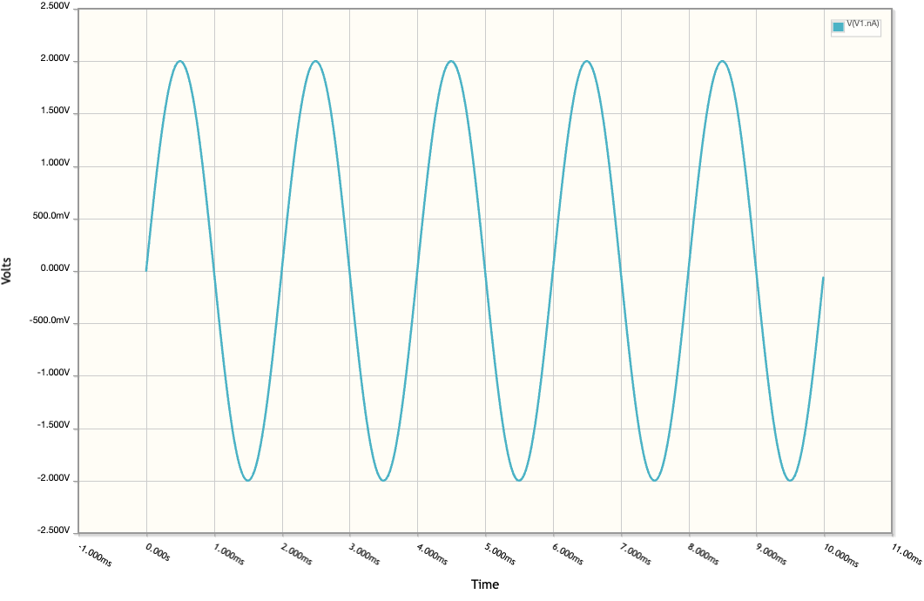

Voltage Across a $1kΩ$ resistor in series with an AC source of $500 Hz$ and peak amplitude of $3 V$

Integrator Circuit

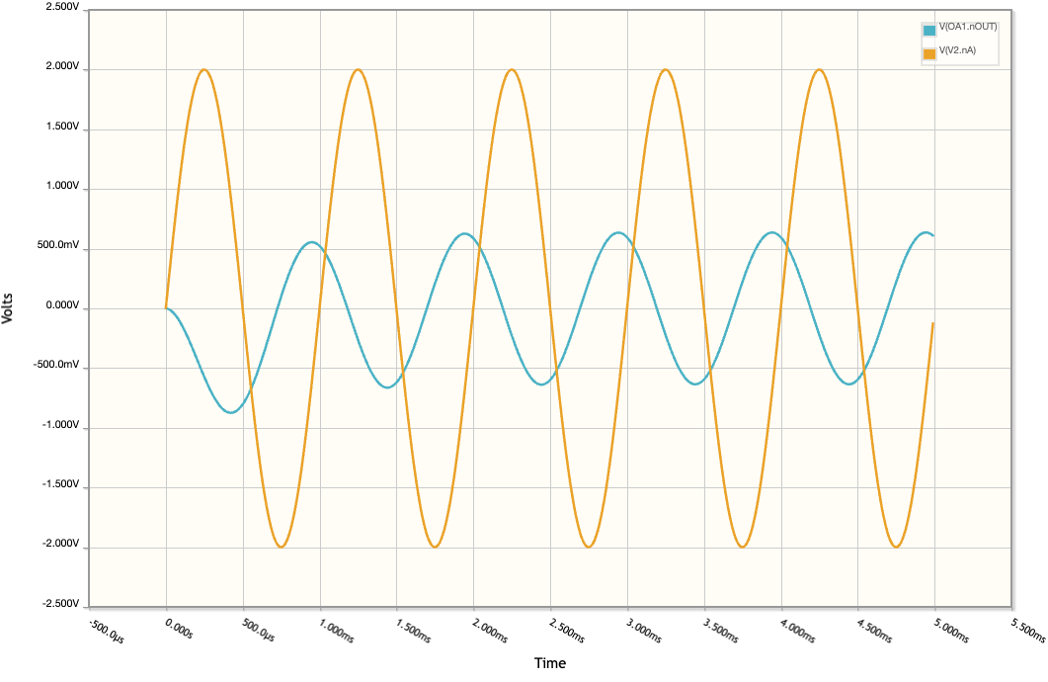

A. Output Response to Input Polarity
Since this is an inverting integrator, the output voltage always moves in the opposite direction of the input signal's polarity. When a positive voltage is applied, the op-amp must drive the output downward (negative) to maintain the virtual ground at the inverting terminal, creating a linear negative ramp. Conversely, when a negative voltage is applied, the output ramps upward (positive). For a continuous waveform like a sine wave, this results in a phase shift where the output peaks (the blue line in your graph) occur exactly when the input (orange line) crosses zero.

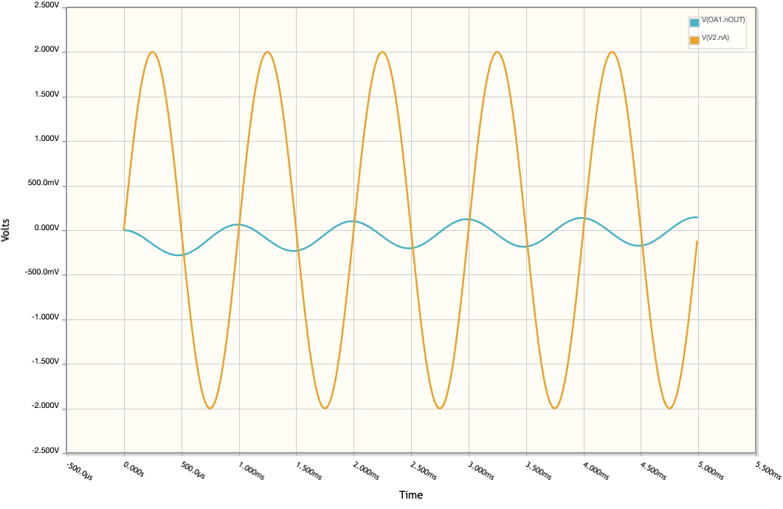
Increasing the capacitance to 20 nF

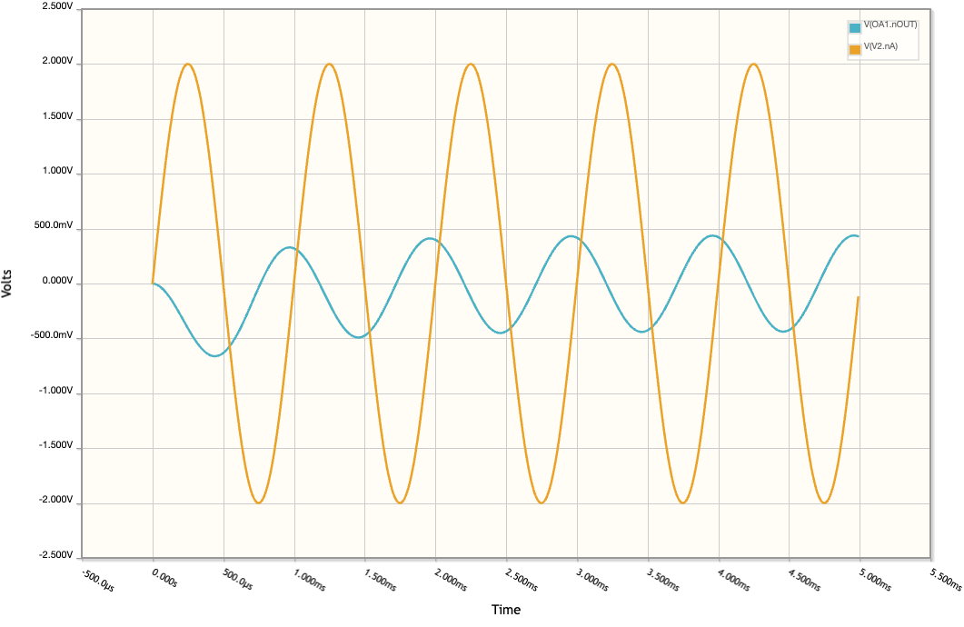
Increasing the resistances Ri and Rf to 150 k$Ω$

B. Effect on increasing R or C
Increasing the value of either the input resistor $\left(R_{1}\right)$ or the feedback capacitor $\left(C_{1}\right)$ increases the circuit's time constant $\left(τ=R_{1}C_{1}\right)$, which reduces the rate at which the capacitor can charge and discharge. As seen in your first image with the 20 nF capacitor, the output amplitude is significantly smaller (roughly 200 mV) because the larger capacity requires more charge to change the voltage. Similarly, your second image with the 150 resistor shows a reduced amplitude (roughly 450 mV) compared to the original because the higher resistance limits the current flow into the capacitor. In both cases, increasing thes

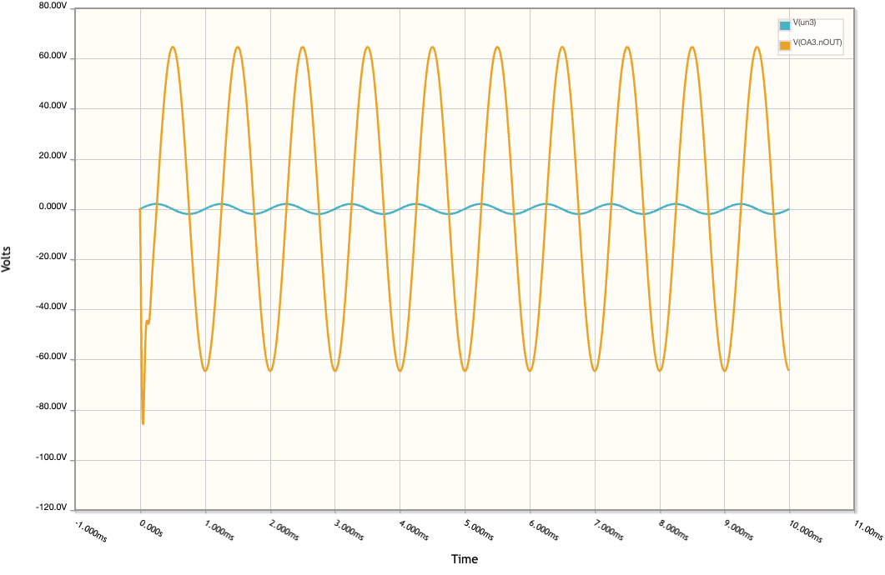

A. Output Response to Input Polarity
In an inverting differentiator, the output voltage is determined by the derivative of the input: $V_{out}=-R_{1}C_{1}\frac{dV_{in}}{dt}$. When a negative-going voltage is applied (a negative slope), the derivative is negative, which causes the inverting output to swing positive. Conversely, when a positive-going voltage is applied (a positive slope), the output swings negative. It is important to note that if the input voltage is a constant "static" positive or negative DC value, the rate of change is zero, and the output will be 0V.

B. Effect of Slow vs. Fast Rate of Change
The magnitude of the output is directly dependent on how quickly the input voltage changes $\left(dV/dt\right)$. If the input changes at a slow rate (a shallow slope), the capacitor charges slowly, resulting in a low-amplitude output. If the input changes at a fast rate (a steep slope), the capacitor must charge rapidly, requiring more current through the feedback resistor and resulting in a high-amplitude output. In terms of waveforms, a triangle wave input creates a square wave output, where the height of the square wave increases as the frequency (and thus the slope) of the triangle wave increases.

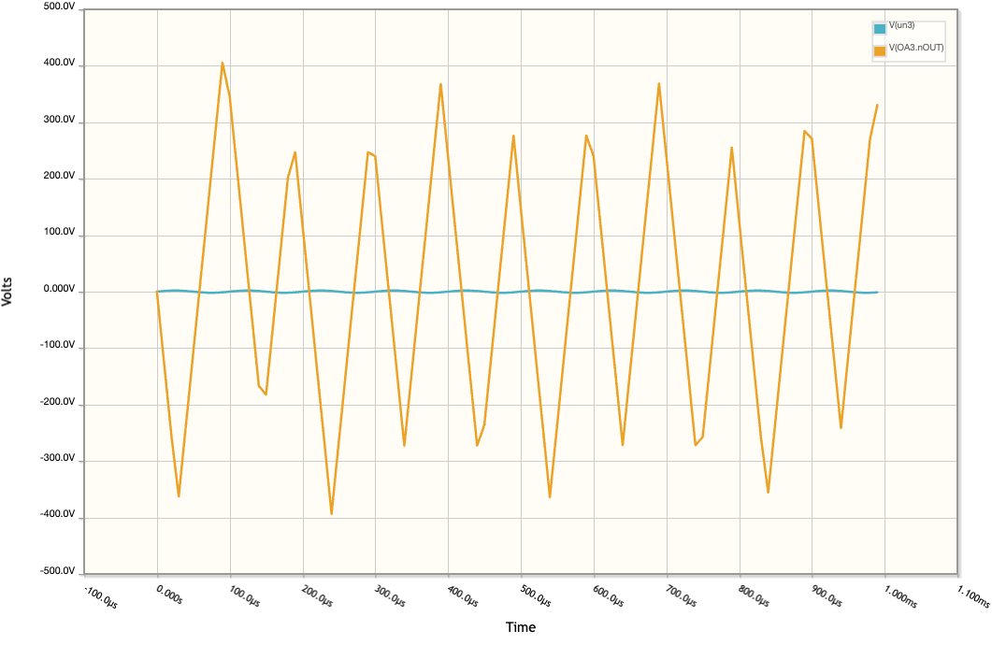
The result of increasing the frequency can be seen here. By increasing the input by $10 kHz$ and adjusting the time domain accordingly by a magnitude of 10, we can see a triangle waveform for the output.

